Sam McDowell

7/10/2020

Lab 4-1.1

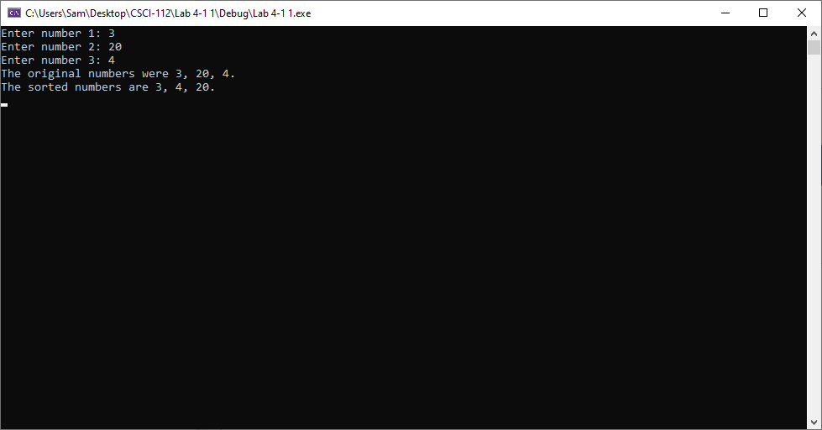

# Transcription:

Enter number 1: 3

Enter number 2: 20

Enter number 3: 4

The original numbers were 3, 20, 4.

The sorted numbers are 3, 4, 20.